**Assignment – 3**

**Sense-Making of Computing Technologies**

**5G Deployment**

The growth of the internet and networks are increasing at a tremendous speed. In the current era of technology, 4G is the latest connection and seems to be the fastest until now. The 5G can be defined as features holding the fast speed, low latency and capable to connect more technologies. The 5G is incremental of the 4G with respect to speed, liability, and the data transfer. The future depends on the connectivity, with the invention of self-driving cars to the robot delivering groceries at your place. Every electronic device is dependent on the network with the internet. The main issue for any wireless industry to get permission to run the network on more towers from the government.[1] The other reason for the United States to implement the 5G network is the cost and execution for installing the fibers. If the nation deploys the 5G network it will help them in the ways that you won't have imagined. The IoT devices and artificial intelligence will be grateful to have. The self-driving cars with the connection of this fast bandwidth will able to communicate with other vehicles while on the road. It will be able to avoid tragedic accidents. Since the 5G network has low latency, it can be beneficial in the industrial and construction works for handling the heavy machines and operate it remotely without any issues.

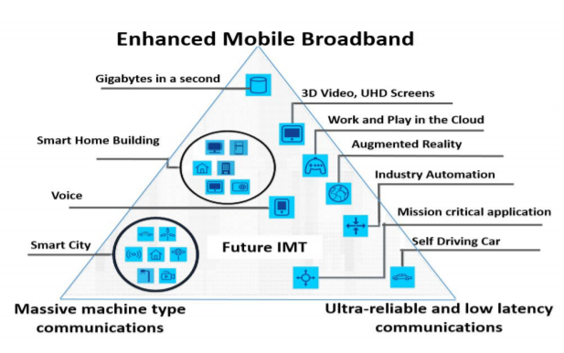

Figure 1: 5G Usage Scenario *(Source: ITU)*

The other major reason that can be beneficial can be health care, the devices that are enhanced with mobile broadband can help to reduce the latency with 5G. Hospitals will be able to create a network-censored pill called ePill, which helps the patient to take the medication and heal from certain diseases.

**Bibliography**

[1] D. K. Rath and A. Kumar, “A Primer on Internet of Things Ecosystem and 5G Networks,” in *2018 International Conference on Information Technology (ICIT)*, 2018, pp. 233–238, doi: 10.1109/ICIT.2018.00055.

[2] R. Montero, F. Agraz, A. Pagès, and S. Spadaro, “End-to-End 5G Service Deployment and Orchestration in Optical Networks with QoE Guarantees,” in *2018 20th International Conference on Transparent Optical Networks (ICTON)*, 2018, pp. 1–4, doi: 10.1109/ICTON.2018.8473996.

[3] J. F. Valenzuela-Valdés, Á. Palomares, J. C. González-Macías, A. Valenzuela-Valdés, P. Padilla, and F. Luna-Valero, “On the Ultra-Dense Small Cell Deployment for 5G Networks,” in *2018 IEEE 5G World Forum (5GWF)*, 2018, pp. 369–372, doi: 10.1109/5GWF.2018.8516948.

[4] F. Gabriel, G. T. Nguyen, R.-S. Schmoll, J. A. Cabrera, M. Muehleisen, and F. H. P. Fitzek, “Practical deployment of network coding for real-time applications in 5G networks,” in *2018 15th IEEE Annual Consumer Communications Networking Conference (CCNC)*, 2018, pp. 1–2, doi: 10.1109/CCNC.2018.8319320.